Write a Python program to extract all URLs (web links) from a block of text using regular expressions. Use the Cursor AI tool with zero-shot prompting to generate the solution

Prompt:Write a python program to extract all the weblinks form a block of text by using regular expressions.dispaly the result on to the screen.

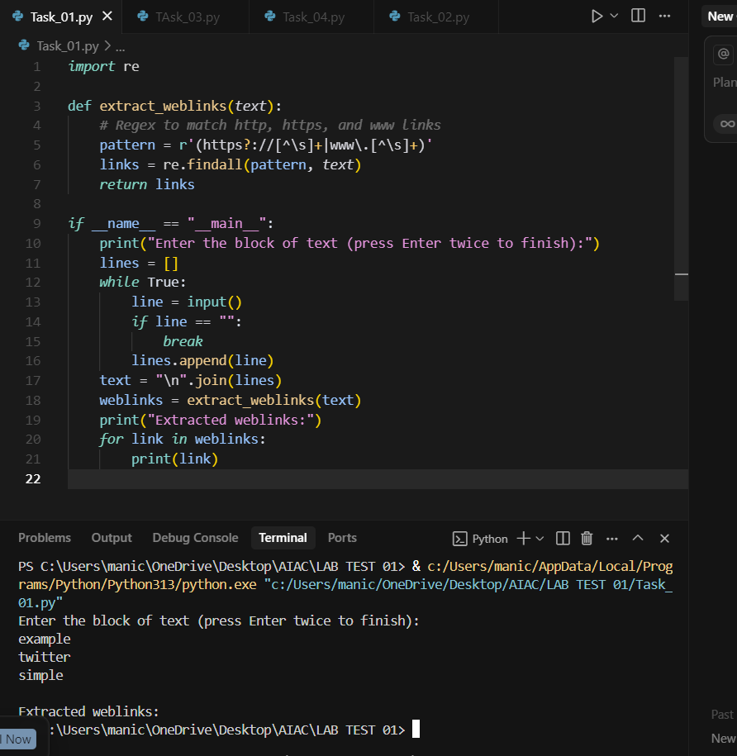

Given a list of books with their genres, write a Python function that recommends books based on a user’s preferred genre. Use the Cursor AI tool. Use few shot prompting

Prompt: ask the user to give the book name and genre of that book write a pyhton program to select the book by entering the user prefereed genre .

Ex:book name=avengers,genre=sci fi,book found

Ex;name=motu,genre=comic,book found

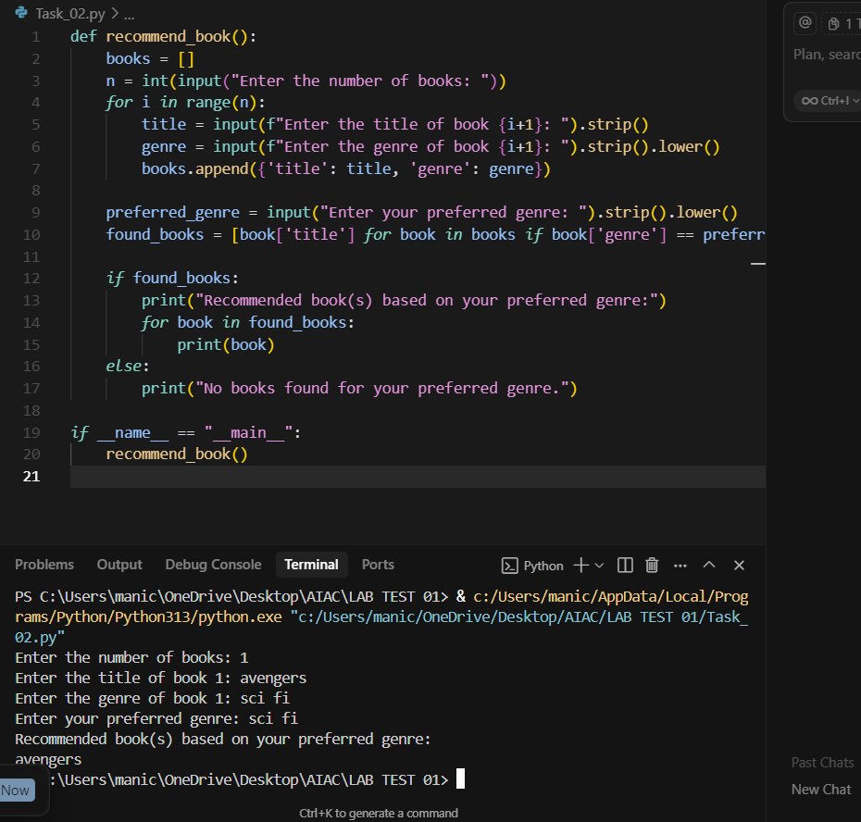

Write a Python program that generates all prime numbers between start and end (both inclusive) entered by the user. Use GitHub Copilot along with VS Code. Use few shot prompting

Prompt: write a pyhton function to calculate the all the prime numbers between given range including first and last name .diaplay all the pri,e numbers

Ex:first no=1

Seconf no=5

Prime numbers=2,3,5,

Ex2 first no=5

Last no=10

Prime no=5,7

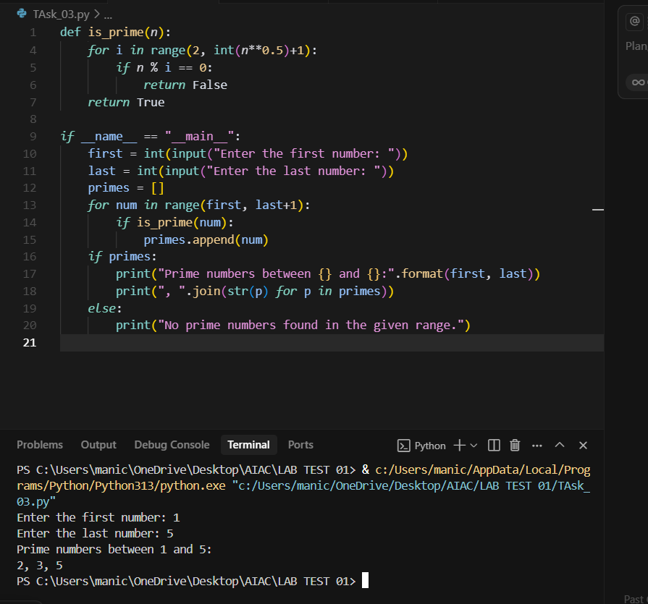

Write Python code that takes a list of student names and generates institutional email IDs in the format: @sru.edu.in Example: "Anita Sharma"→ asharma@sru.edu.in. Use GitHub Copilot along with VS Code. Use few shot prompting.

Prompt:

Wite a python program to create clg student maill ids by entering the first and last name of student.combine both name and add @sru.edu.in at last

